**Session 1: HDFS**

Assignment 1.4

**Student Name**: Karthik K

**Course**: Big Data Engineering with Hadoop & Spark

**­­Task:3**

Create a file max-temp.txt in local FS.

Put some 10-15 records of date and temperature example: dd-mm-yyyy,temperature

Example:

10-01-1990,10

10-02-1991,20

Move this file to HDFS at /user/acadgild/hadoop.

**Solution**: Create a file locally and using –Put command move the file to the above destination.

**Output:**

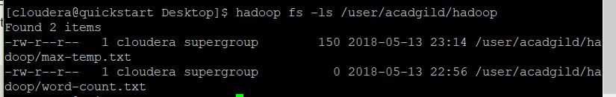

**Task 3 Completed.**

**Task: 4**

Change the permission of the file /user/acadgild/hadoop/max-temp.txt, such that only the owner and the group members have full control over the file. Others do not have any control over it.

**Solution**: To change the permission of the file, we use –chmod command.

**Output:**

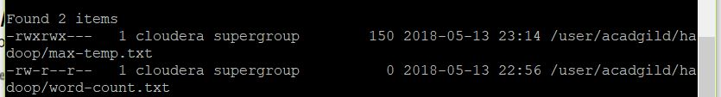

**Task 4 Completed.**